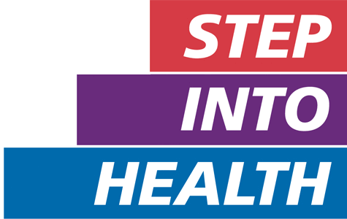
Welcome to Step into Health, we work to support the Armed Forces community to access the career opportunities available in the NHS

How it works
Step into Health is made up of NHS organisations which have pledged their support to the programme.
Through Step into Health, members of the Armed Forces community can connect to NHS organisations to set up training opportunities, clinical and general work placements, insight days and receive application support. The programme provides a dedicated pathway into a career in the NHS.

Who it is for
Step into Health is open to all service leavers, reservists, veterans, Cadet Force Adult Volunteers and the families of all of these.

Why work in the NHS?
There are more than 350 clinical and non-clinical roles within the NHS. Whatever your background, previous work experience and qualifications, you can find something that is suitable for you.
NHS organisations recognise the values and transferable skills that the Armed Forces community bring and recognise their compatibility with NHS roles.
Find out more about the different roles available and access career guides on the NHS jobs website.

What you can expect from Step into Health
NHS organisations that have pledged to Step into Health have dedicated people you can talk to about opportunities within their organisation. They will be able to provide more information on the careers available within their organisation, work placements, information days, give application guidance and answer questions on the wider NHS.
After registering yourself on our system, you’ll be able to get in touch with one our Step into Health contacts and speak directly to a dedicated person or team about opportunities within their organisation. Please note that due to the nature of COVID-19, volunteering, insight days, work experience or shadowing opportunities may not be available at this time. However, NHS employers are still on hand to offer recruitment support and advice regarding working in the NHS.

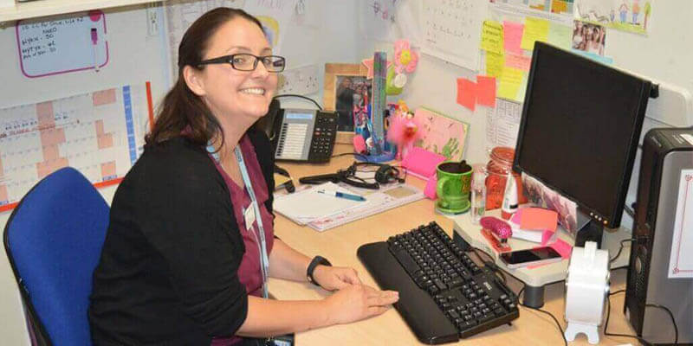Success stories
Read our case studies from those

Sarah Learney
NHS Programme & Operations Director
As a veteran enjoying a successful career in the NHS, I knew where to go when I needed project managers.
As an NHS recruiter, I found members of the Armed Forces community:
- get up to speed and add real value quickly
- offer transferable skills (leadership, management, adaptability, teamwork, etc.
- are solution-focused and value-driven
- are a great cultural fit to the NHS, and this understanding has been reinforced during pandemic.
Read our case studies to discover how managers across the NHS support their Armed Forces community employees.
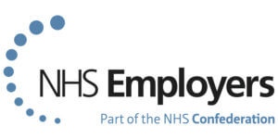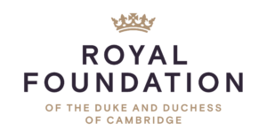

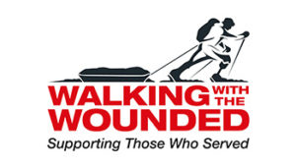
Step into Health has been developed in partnership with NHS Employers, The Royal Foundation and Walking with the Wounded.
Images used subject to © Crown copyright

