

Training Courses Request Form 2021

Date of request

Name

Job Title/Role

Department/Site

Telephone/Bleep

Email

Please indicate which session(s) you would like to attend from the course dates offered on the following pages, all training will be via MS Teams until further notice.

Course Preferred Date/Time

Confirmation of the courses/dates you have requested will be sent to you by email. Certificates will be available from the library following the training.

Please return the completed form in full to:
Library, Education Centre, BVH, Blackpool, FY3 8NR
Tel: 01253 953831 Email: bfwh.library.services@nhs.net

'Privacy Information: your privacy is important to us. Your personal details are collected here for the purpose of providing the services you have requested and will not be used for any other purpose. Please see the library Terms and Conditions for details of how we store and use your information'.

Training Courses – February to November 2021

Accessing the Electronic Journals and Books

All training will be via MS Teams until further notice


Session Content: We offer a 30 to 60 minutes drop-in course, which will show you how to access and use the HEE Core/Regional collection and Trust Library collection of electronic journals and books.
Main Topics: Introduction to accessing the electronic journals and books from the Library’s web pages, Intranet and NHS Evidence website; enabling you to navigate through the collections and access the full- text.

1 Point to your CPD and Revalidation, Certificate available

To arrange a 1 to 1 on the above, please contact Laura Sims on 56688 or laura.sims2@nhs.net

Searching NICE Healthcare Databases - Basic and Advanced

(HDAS Interface)

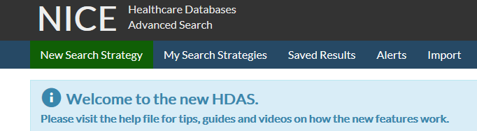
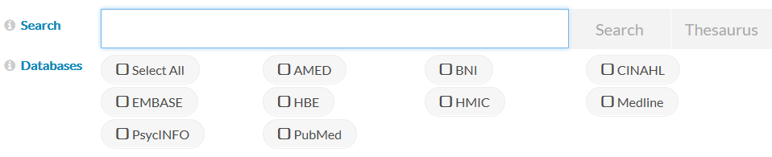

Session Content: We will be offering 60 mins courses on the Healthcare Databases (HDAS) Basic and Advanced; which will show you how to access and use the NHS Collection of primary databases* to locate relevant research and literature quickly and effectively.
* NHS Collection of databases has all of the major sources of published primary research including: AMED, British Nursing Index; CINAHL, Embase, Medline, HMIC and PsycINFO

Main Topics: Introduction to main functions and search capabilities of the databases - How to conduct a literature search with new Interface - Using subject heading thesaurus to locate documents, use filters and limits. Saving searches and creating Alerts.

Dates:

BASIC
February Wednesday 17th 11:00 am
March Wednesday 10th 11:00 am
April Wednesday 7th 11:00 am
May Wednesday 5th 11:00 am
June Wednesday 2nd 11:00 am

September Wednesday 1st 11:00 am
October Wednesday 13th 11:00 am
November Wednesday 10th 11:00 am

ADVANCED

February Wednesday 24th 11:00 am
March Wednesday 17th 11:00 am
April Wednesday 21st 11:00 am
May Wednesday 19th 11:00 am
June Wednesday 16th 11:00 am

September Wednesday 22nd 11:00 am
October Wednesday 27th 11:00 am
November Wednesday 24th 11:00 am

1 Point to your CPD and Revalidation for each course, Certificates available

Drop-In Sessions New Resources



Session Content: We will be offering a 60 mins drop-in session on accessing a number of new evidence resources on the Trust Intranet; which will show you how to access and use the Collection of resources that the Library has provided to support staff in Patient Care, Education, Research, Policy review, Audit and Service Innovation.
Main Topics: Introduction to main functions and search capabilities of the resources - How to use the Interfaces of the resources - Using subject headings, chapters, thesaurus to locate documents, procedures and images

1 Point to your CPD and Revalidation, Certificate available

To arrange a “Drop-In” on the above, please contact Michael Reid on 53338 or michael.reid1@nhs.net

Cochrane Library

All training will be via MS Teams until further notice



Session Content: A 90 minutes course which will show you how to access and use the Cochrane Databases; one of the best single sources of reliable evidence about the effectiveness of health care. Cochrane Database includes: Cochrane Database of Systematic Reviews; Cochrane Clinical Trials Register and Clinical Answers.

Main Topics: Introduction to the Cochrane Databases - Main functions and search capabilities of the databases - How to perform a literature search within the databases - How to navigate the full text of a Cochrane review article and other results.

Dates:

February Thursday 22nd 10:30 am
March Wednesday 24th 10:30 am
April Wednesday 14th 10:30 am
May Wednesday 12th 10:30 am
June Wednesday 9th 10:30 am

September Wednesday 15th 10:30 am
October Wednesday 20th 10:30 am
November Wednesday 17th 10:30 am

1.5 Points to your CPD and Revalidation, Certificate available

'Privacy Information: your privacy is important to us. Your personal details are collected here for the purpose of providing the services you have requested and will not be used for any other purpose. Please see the library Terms and Conditions for details of how we store and use your information'.

