V&SCP Panel Process Procedure/Flow

The V&SCP panel will now review all requests for new posts, recruitment into existing posts and pay impacting changes that have a financial impact on the Trust, except for roles not in scope. (Please see appendix A)
For a request to be considered at the V&SCP Panel, the manager (Requestor) must complete the TRAC process or Assignment Change Form as normal.
For a vacancy to be presented to panel, it must have all the necessary approvals in place, which includes DDop (or equivalent), HRBP, Finance & Human Resources (re-deployment purposes), if the role is Band 4 or below you will also need approval from the apprentice team.
You will need to complete a V&SCP justification document and attach to the relevant role in TRAC, which must be completed fully. At this point your vacancy will be presented to the Panel for final approval.
For ACF’s (Assignment change forms), you need to complete on Flowforma, (Sharepoint) as normal, if your ACF requires V&SCP approval, please ensure you provide all the add necessary information required.

The documents can be found on One HR Vacancy & Spend Control Panel (V&SCP) | oneHR (bfwh.nhs.uk) and the email address to submit to is bfwh.vacancyandspendcontrolpanel@nhs.net

All requests received by the deadline will be extracted and presented to the panel. The expectation is that those requests received by 12pm on a Thursday will be reviewed at the meeting the following Tuesday. All requests must be received by no later than 12pm

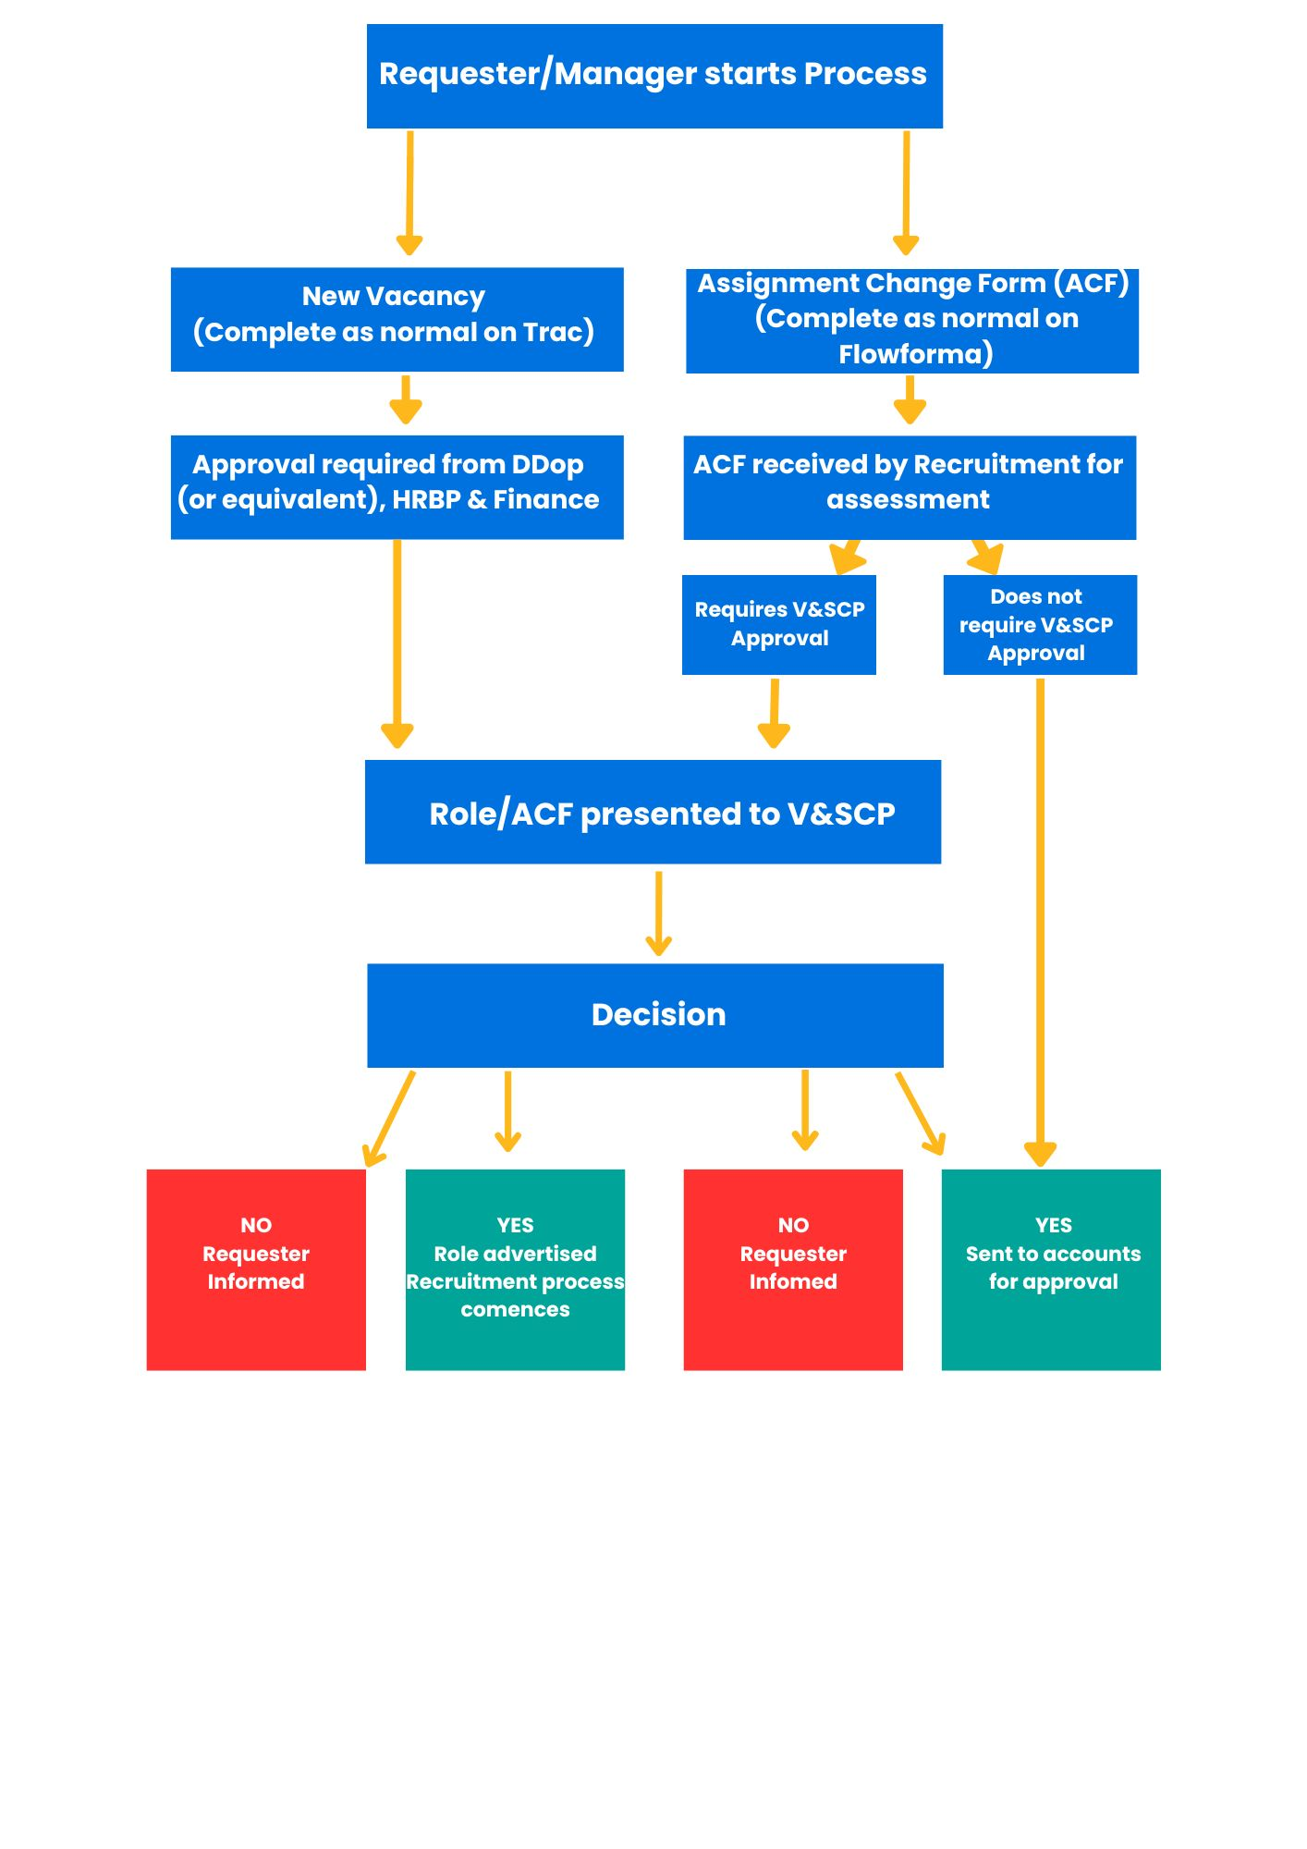

Panel Timeline

The above timescale is dependent on the following:

- completeness and accuracy of the information submitted

- the responsiveness of recruiting managers and others to queries raised

- If insufficient information is provided, then the post will be rejected and returned to the submitting manager to address and a new submission will need to be made

Appendix A

All roles with the exception of those listed below will be subject to V&SCP.
Roles exempt:
- Band 5/Band 6 Nurses
- Medical & Dental
- Allied Health Professionals
- HCA’s
- Ward/departmental managers such as Radiology, Pharmacy, Speech and Language, Physiotherapy etc
- Matrons
- Clinical Leads
- Resus trainers
- Advanced Practitioners
- Senior Nurse Managers
- Hospital at Night and OHH
- Consultants with PA’s for a management role
- Educational Supervisors
- Safeguarding Leads
- Infection prevention (IPC)
- DOLs
- Mortuary Managers
- Theatre Managers

