Terms of Reference and Detailed Process: Vacancy & Spend Control Panel (V&SCP)

Version: 6
Date: 4th Dec 2023

- Introduction

  - The Vacancy & Spend Control Panel (V&SCP) was introduced to the Trust as an executive scrutiny measure with the aim to improve the financial position of the trust and ensure that investments in staffing provide the best fit option for the Trust’s workforce.

  - From 15th May 2023, the purpose of the V&SCP will provide a more strategic overview of resource allocation and increase overview and scrutiny of transactional approvals.

- Why is V&SPC Being Introduced?

  - Whilst the original Vacancy Panel has been successful, there is a need to have scrutiny over all changes to establishment that have financial implications.

  - Scope: All types of staff are in scope with the exception of Medical and Dental Staff & certain roles (please see appendix), These are recognised as our most challenged areas to recruit to.

- The Purpose of the V&SCP

  - The purpose of the V&SCP is to add value to the Trust by.

- providing a mechanism to enable all people and workforce managers at all levels of the Trust to forward plan and make best utilisation of their workforce resources
- enabling managers to give assurance to the executive team that workforce spending is managed effectively and appropriately at operational management levels
- to ensure there is adequate scrutiny and control of some investments in workforce spending at the organisations most senior management levels
- to ensure that there is a process enabling robust planning, thought and purpose in the staffing investments made by the trust in order that the ‘best fit’ workforce option is used in both short term and long-term resourcing
- provide assurance to the executive team that managers, finance, and HR are working together in an effective partnership to ensure that we have the ‘right staff, in the right place at the right time and with the right skills’ without any wasted resources or underutilised resources

Please Note: The Trust’s expectations for all A&C and Non-Clinical posts (that are not business critical), is that the recruitment to these posts is delayed for 3-6 months. We are asking Hiring Managers to look at their current resource and look to absorb the work in this way. We welcome Hiring Managers to resubmit their requests after these timescales with further evidence as to why the post is required.

- What does this mean in practice?

  - Due to the Trust’s challenged financial position, there is a need for all changes to establishment and expenditure to be paused and will now be subject to proceed through the V&SCP, approval will therefore now be required for the following operational changes:

- Changes to hours
- AFC Regrade applications
- Acting up or secondment arrangement
- Changes to AFC pay bands or scales incremental credit
- Recruitment activity; new or replacement posts
- Flexible retirement requests
- Commencing salary requests for new starters

- What is the new approval process for recruitment activity?

  - A new approval process will be implemented within the recruitment process using the TRAC electronic system for the following processes:

- Acting up or secondment arrangements
- Recruitment activity; new or replacement posts

  - TRAC will be used as the single point of approval for all vacancies and will require sign off from the following:

- Divisional Director of Operations
- The Divisional Finance Manager
- The Human Resource Business Partner
- Human Resource for redeployment opportunities
- The Apprentice Team (For Bands 1-4 A&C and junior management roles)
- Vacancy & Spend Control Panel (V&SCP)

N.B: Your request must have the approval of the DDop (or equivalent), Divisional Finance Manager, Human Resource Business Partner, Human Resources and the Apprentice Team (where appropriate) before going to the V&SCP for FINAL approval.

  - Most will be familiar with the TRAC approval process if you have advertised posts previously.

Information and guidance to help complete the above authorisation process is included when raising a request on TRAC

The new process also requires you to complete supporting documents to be completed and submitted to bfwh.vacancyandspendcontrolpanel@nhs.net by 12 noon Thursday

  - Following correct submission of the Vacancy & Spend Control Panel Justification form, you will be invited to attend the V&SCP panel via an MS teams invite. These meetings will be held on a Tuesday at 11am). Where it is not possible to attend/Failure to attend the meeting will result in your vacancy remaining on hold until the next available meeting. If you are unable to attend, you can send a deputy.

If insufficient information is provided, then the post will be rejected and returned to the submitting manager to address and a new submission will need to be made
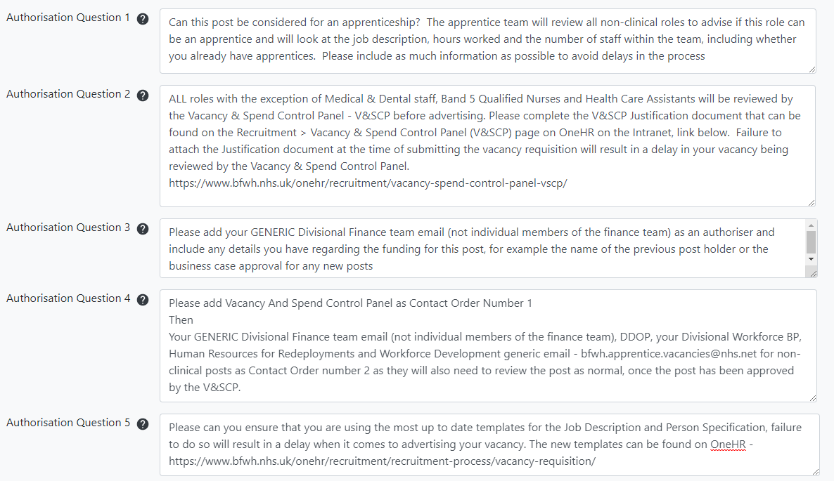

- What are the approval processes for other changes (Assignment Change Forms)?

For example
- Changes to hours
- Acting up or secondment arrangement
- Changes to pay bands or scales
- Flexible retirement requests
- Commencing salary requests for new starters

The above temporary and permanent contractual changes to hours, pay bands or scales, will require completion of the Assignment Change Form as usual which will be assessed as part of the V&SCP approval process.

The new process also requires you to add supporting information when you create the new ACF.

- Review

  - The changes will be reviewed in 6 months to ensure Divisions are maintaining financial control and the Trust financial position is not being negatively impacted by the changes made.

- Membership

Members: Executive Director of People & Culture (Co-Chair)
Executive Director of Finance (Co-Chair)
Deputy Director of Finance (Deputy Chair)
Deputy Director of Nursing
Chief AHP

Members will give due consideration to:

- Review of activity
- Review vacancies
- Premium usage and agency costs rates including breached cap payment levels

- Quorum

  - The business of the group will be conducted in a weekly meeting

  - The quorum for decision making of the panel shall consist of a minimum of three members.

  - Chair and Deputy Chair will be permitted to send delegates to represent them in their absence.

  - Any incomplete forms will not be considered.

  - Any late submissions will be ‘rolled’ over to the next meeting.

- Frequency of the meetings

  - The panel will meet weekly (Tuesday at 11am)

  - The scope and remit of the panel is subject to review on a 6-monthly basis this review will be lead and/or commissioned by the V&SCP Chair with their findings fed back to the executive team.

- Timescales for Decision Making

- Timescales for Decision Making

  - Decisions will be made by the panel after the meeting has taken place and will be communicated to the hiring/appointing manager within 24 hrs to confirm whether the vacancy has been endorsed or not.
.

- Appeals

  - There is no right of appeal; however, the request could be resubmitted for reconsideration with supplementary information if necessary and/or based on actions and feedback from the V&SCP.

- V&SCP form filling guidance notes

  - V&SCP forms should be completed in as much detail as possible. The onus falls on the Manager (requestor) to ensure all details are complete and accurate. Should insufficient detail be provided in order for the panel to make a decision, the request will be rejected and a new submission will need to be made.

  - In free text boxes, please do not include any one-line statements. Explain the case fully and provide supporting evidence/rationale for the answer to each question:

- Provide detailed explanations on the impact of quality, patient safety (including examples), and effectiveness

- Where quality would be impacted, name the relevant quality standard or guideline, and provide supporting evidence as applicable

- Provide detailed rationale, and quantify the expected annual savings by comparing the hourly/daily rate of the role being applied for, vs the role being replaced (as applicable)

- Where not possible to generate savings, as stated above one-line statements will not be accepted. Note that in the trust’s current financial position, it will be difficult for the panel to approve a post that does not generate savings, or provide more income to the trust than the cost of the post

- Authority

  - Authority for this panel to make decisions is given from the CEO and Executive Director of people & Culture via Workforce Committee

Appendix A
Roles which are exempt from V&SCP
- Band 5/Band 6 Nurses
- Medical & Dental
- Allied Health Professionals
- HCA’s
- Ward/departmental managers such as Radiology, Pharmacy, Speech and Language, Physiotherapy etc
- Matrons
- Clinical Leads
- Resus trainers
- Advanced Practitioners
- Senior Nurse Managers
- Hospital at Night and OHH
- Consultants with PA’s for a management role
- Educational Supervisors
- Safeguarding Leads
- Infection prevention (IPC)
- DOLs
- Mortuary Managers
- Theatre Managers

