Please see the information below on the location of the Accommodation Office.
The Accommodation Office is located in the main hospital building.
- To reach the Accommodation Office go through the main entrance and up the escalators.
- Go past the stairs to the restaurant and down the main corridor.
- Go down the main corridor until you see the sign for X-Ray Central, Acute Stroke & Rehab Unit and Wards 34 & 35, turn left down that corridor.
- Follow the corridor down to the Acute Stroke Rehab Unit sign where you will turn right.
- Go up the stairs to the first floor where you will find Wards 34 & 35, turn left, and go to the door marked Facilities, Services & Emergency Planning.
- A member of the Accommodation Office will need to let you through the door if you do not have a badge or it does not grant you access. Please ring: 01253 (9) 53772
- Once inside turn left and go down the corridor until you reach the Facilities Training Room door. Turn left here.
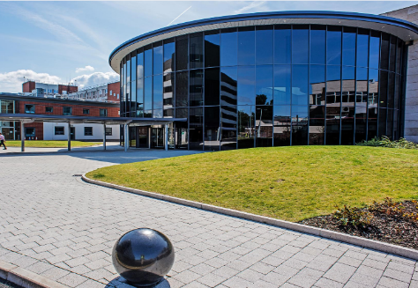
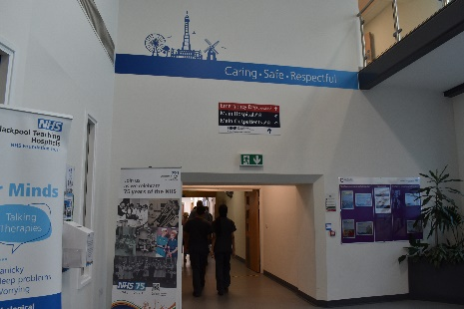
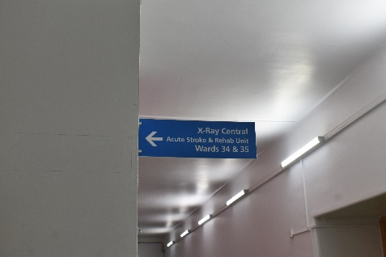
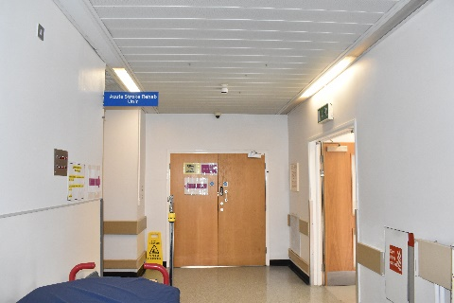
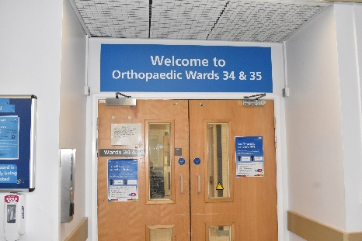
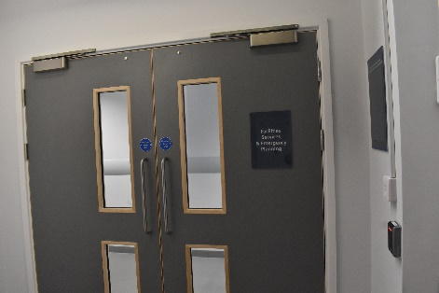
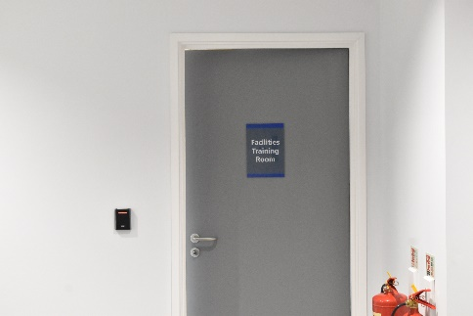
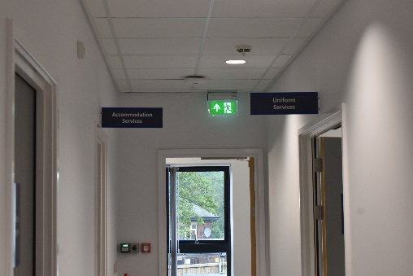
- Follow the corridor round until you reach the Accommodation Office at the end.

