Please see the map below for information on the location of the Fit Testing Cabin.
The Fit testing cabin is located next to the Occupational Health Building.
You can either go through the main entrance and follow the main corridor all the way down to Outpatients. Once Outside please carefully navigate the car park and road. The Occupational health house is across the road.
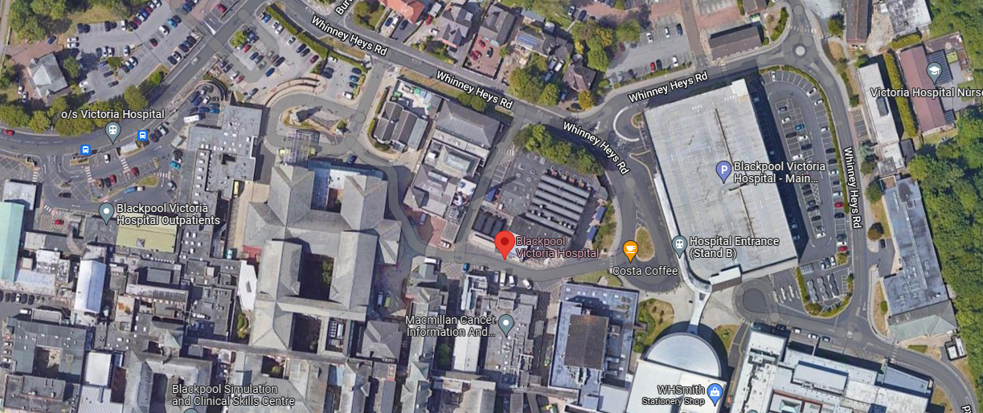
Alternatively turn right out of the education centre and follow the pathways around the main car park and down Whinney Heys Road. Past A&E turn left onto Whinpark Avenue.
You are here.
Fit testing Cabin
Main entrance

