# ePay Registration pt1.

1. Type the following web address into your internet browser:

**https://www.epay.sbs.nhs.uk:8571/epay/esr.elogin**

3. Complete the required fields within the form (Org No 331)

*Please note all fields are mandatory*

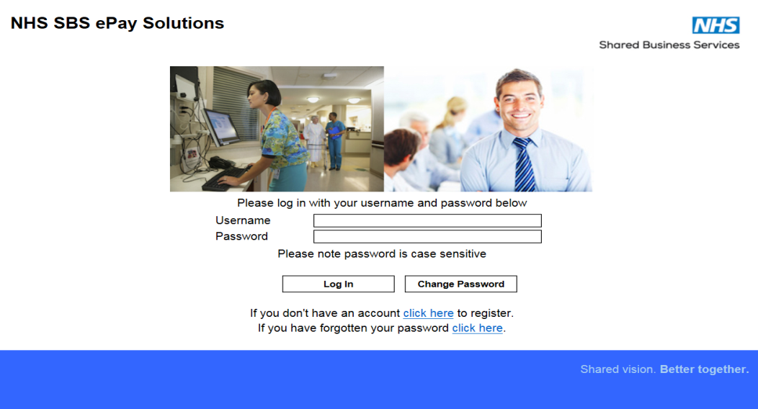 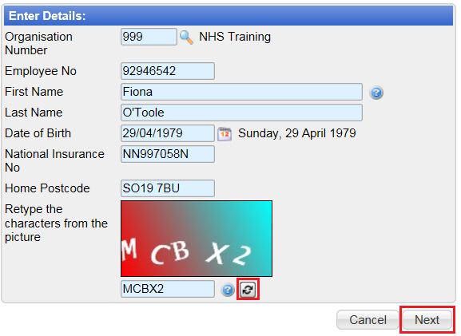

2. To register for ePay click the ‘Click here’ link

*4. If the characters are not clear click the* ***‘Refresh’*** *icon for a new set*

5. Click ‘Next’

# ePay Registration pt2.

9. Read and confirm the **‘Terms and Conditions’** by placing a **‘Tick’** in the box

# 

6. Create a password with a minimum of 8 characters with at least 1 uppercase, 1 lowercase and 1 number

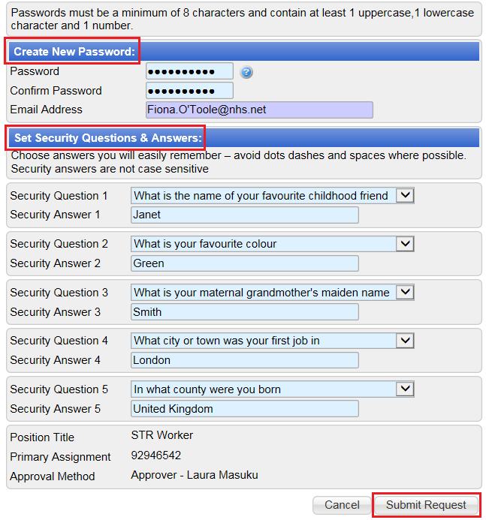

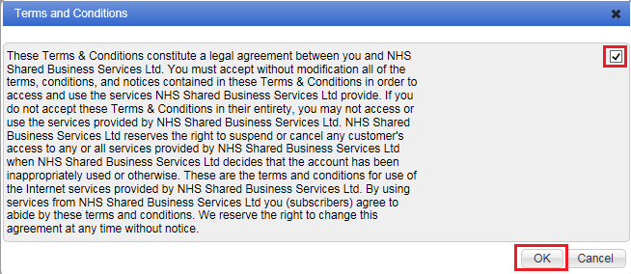

10. Click ‘**OK**’

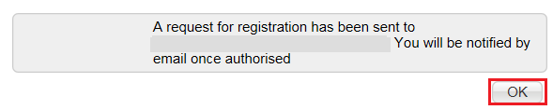

11. Check that the correct person/email has been listed within the confirmation message and click ‘**OK**’

If the wrong person / email is listed please contact:

*Insert ePay administrator email address here*

7. Select 5 security questions from the dropdown lists. In order to reset the password in the future, the user will be asked 2 of the 5 questions. Responses are to be in the same character set as entered in the ‘Security Answer’ field

8. Click ‘**Submit Request’**

# ePay e-learning pt1.

# 

2. Click the e-learning link

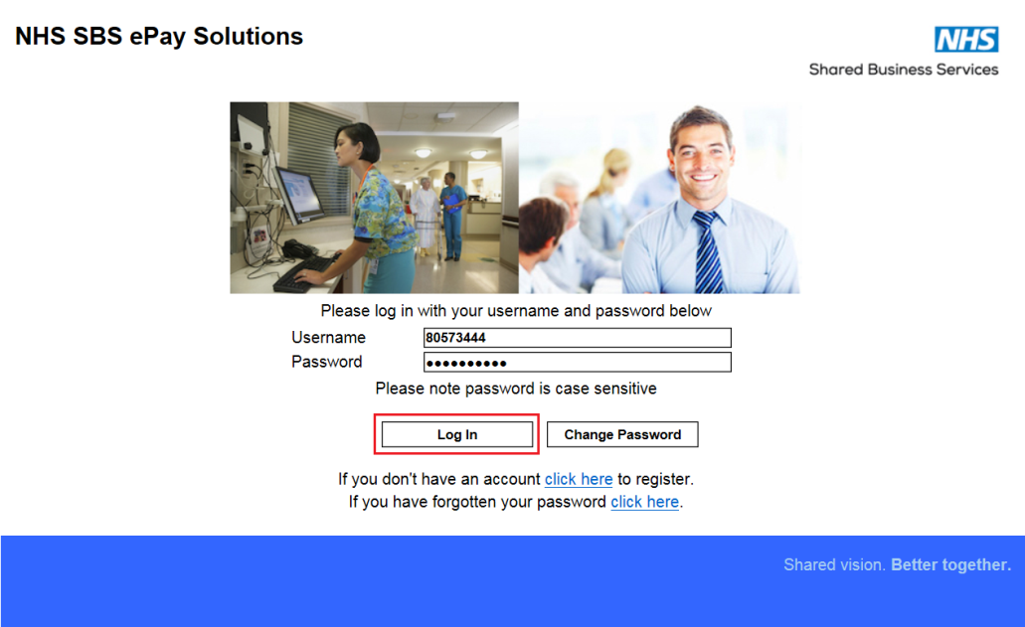 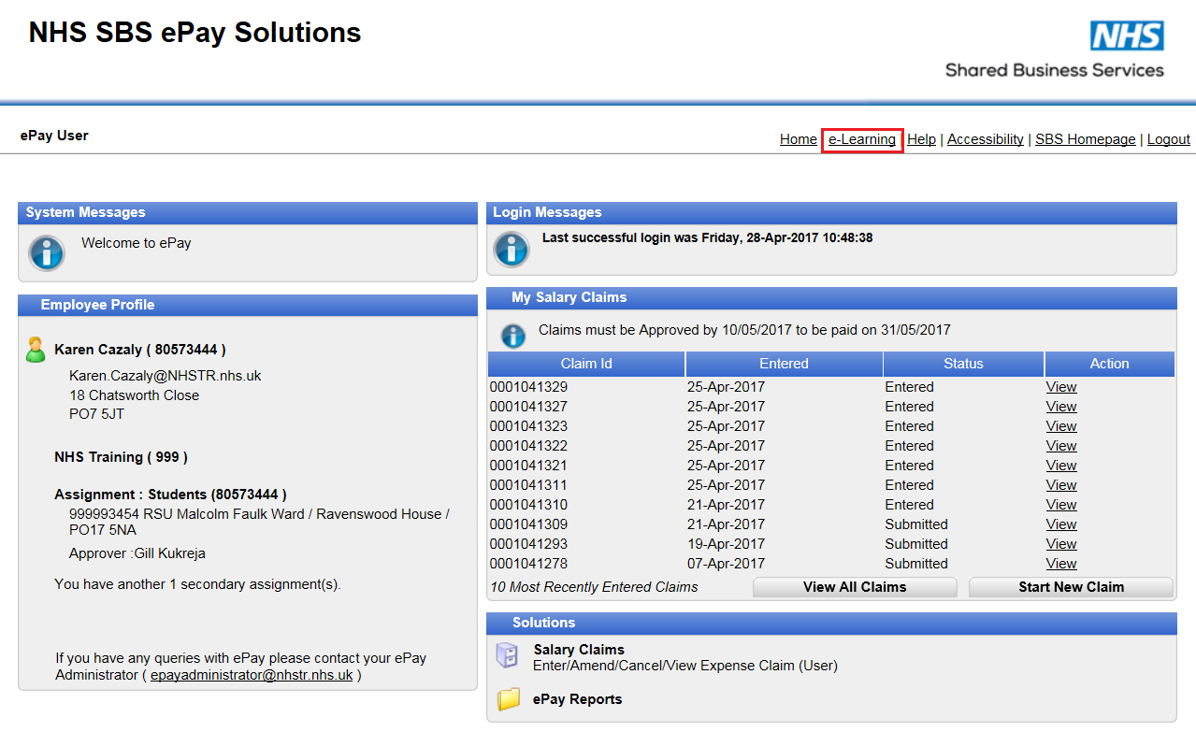

1. Enter the username and password. Click ‘Log In’

# ePay e-learning pt2.

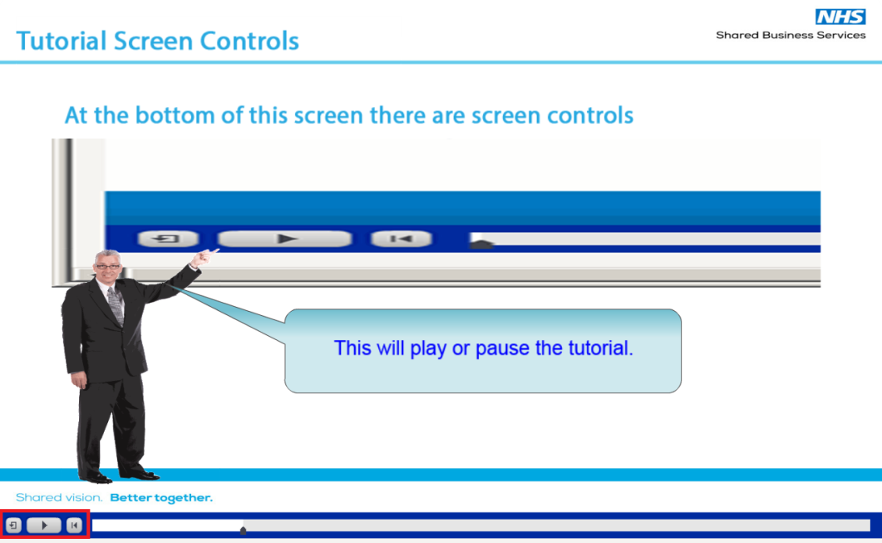

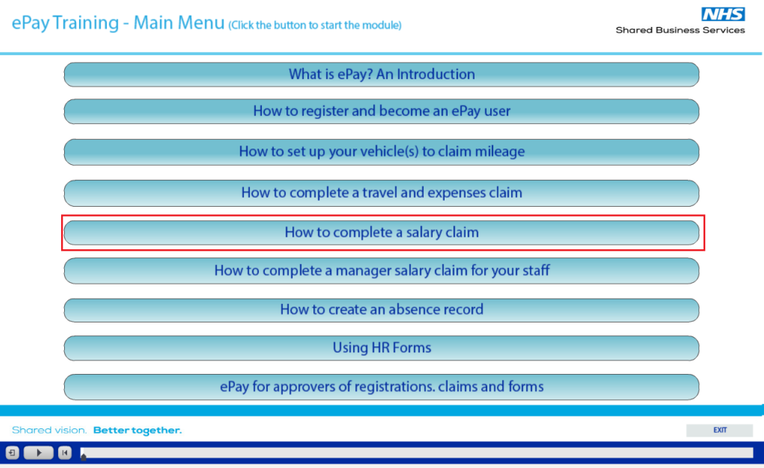

4. When the Main Menu has loaded, click the required module, for example ‘How to complete a salary claim’

3. The introduction will play automatically. Use these buttons to navigate or pause the tutorial if required

# ePay e-learning pt3.

# 

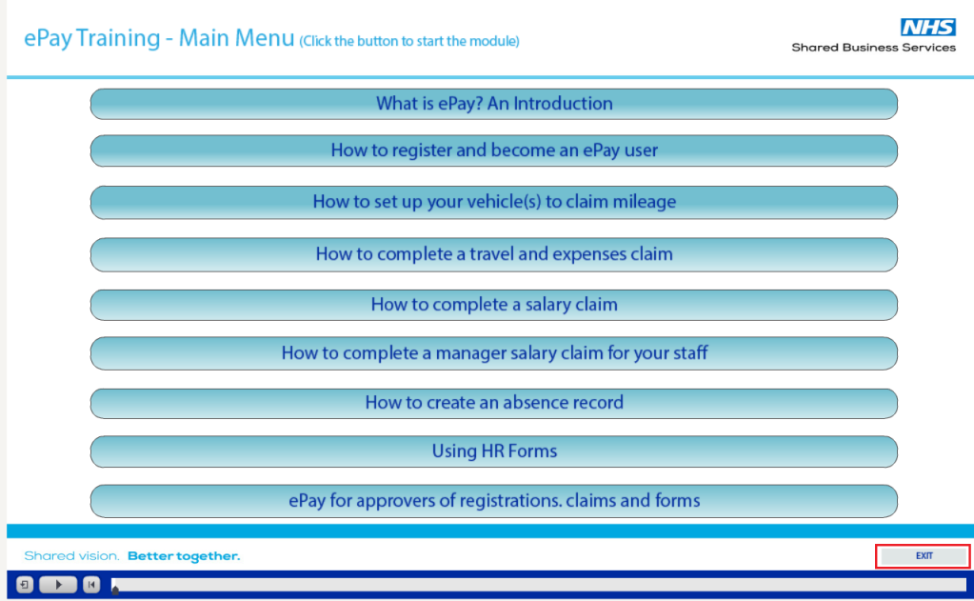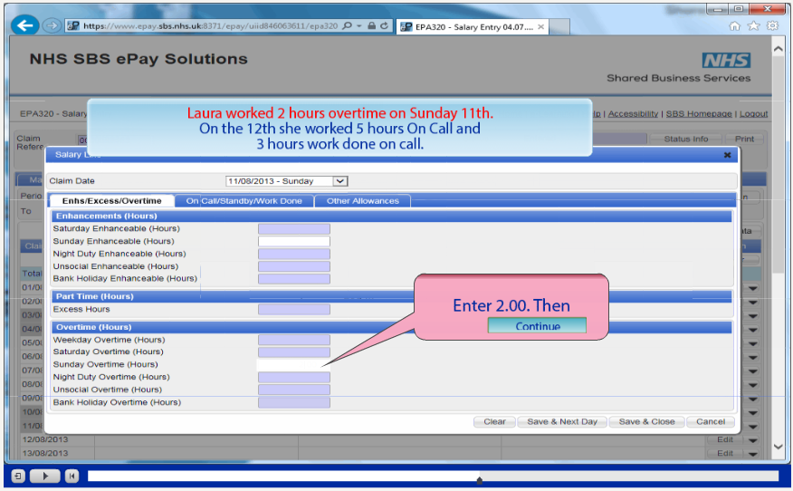

6. The module will re-direct to the Main Menu when completed. Click ‘Exit’ to close

5. The selected e-learning module will play like a video, pausing at certain stages for the user to practice using ePay within the e-learning screen, as shown

# 